**Profile.me** update instructions from v1.7 – v1.8

**Step 1**: Backup! You must backup your all files & database before update.

**Step 2**: Download the latest profile.me_1.8 script file and extract it on your pc. Open **updates > update_v1.7_v1.8 > uploads**  folder you will see **three files** in there and you need to upload this files in your project please follow the directions below.

1. **application.zip** > upload path: Goto your **project root folder > application** upload this zip file and extract it.
2. **assets.zip** > upload path: Goto your **project root folder > assets** upload this zip file and extract it.
3. **config.zip >** upload path: Goto your **project root folder > application >** **config** upload this zip file in this folder and extract it.

**Step 3**: Upload **“updates”** folder in your project root folder

**Step 4**: Open a browser and write url like this: [www.yourdomain.com/update](http://www.yourdomain.com/update)s/update_v1.7_v1.8 You will see a page like below here enter your item purchase code for update this script.

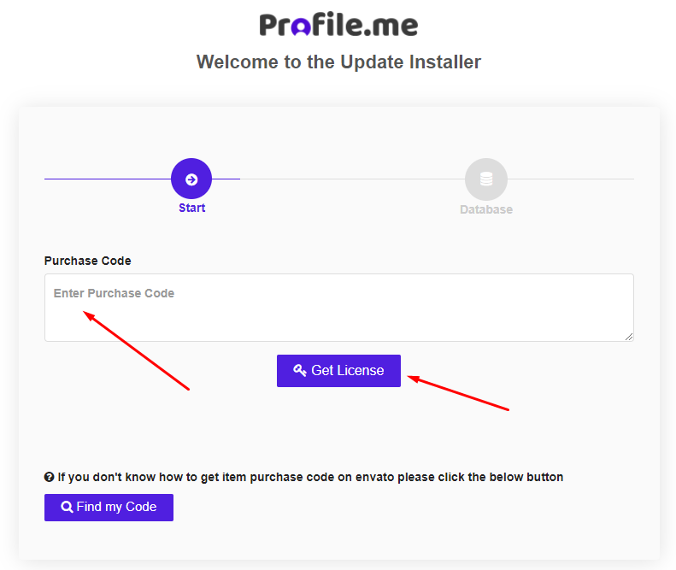

**Step 4**: Here provide your current database credentials and wait few seconds for update your scripts.

